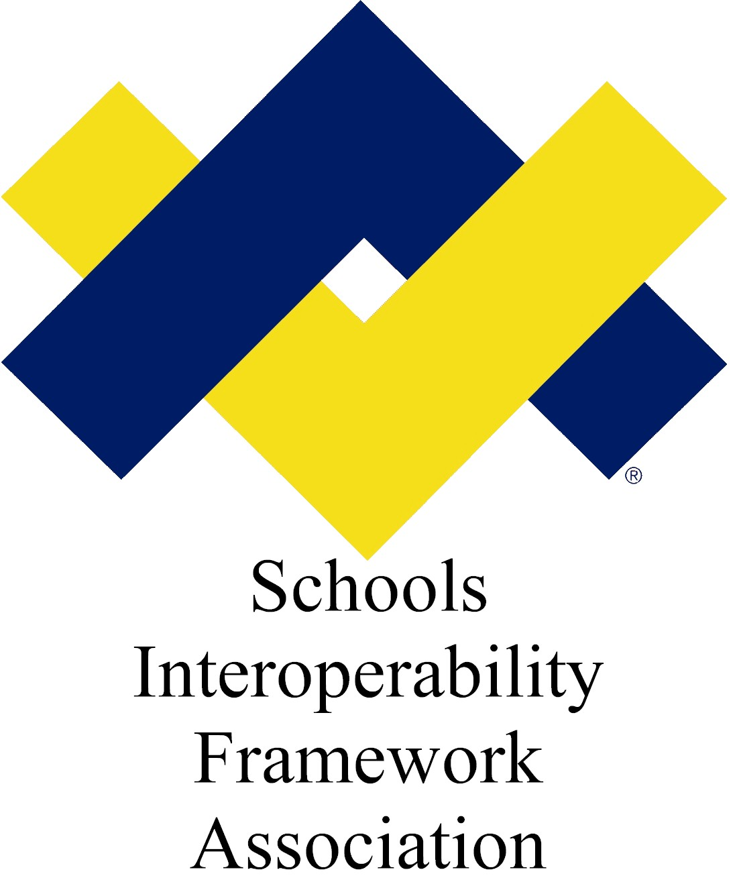

SIF Change Proposal: StudentSpecialEducationRecord

Submitted by: Student Record Exchange Task Force
Version: v0.91
Date Submitted: 9/1/2009

Table of Contents

Change Proposal 2
Business Case 2
Time Line 2
Potential Object Changes 2
Object Plan 2
Object Dependencies and Relation Map 2
Changes to Other Objects 2
Infrastructure Changes 2
Object Definition 3
Issues 3
XML Example 3
Use Cases 3
Object name here and what type of object proposed-Request or Event 3
Scenario 1: Name of Object and Scenario Title here 5

Draft Specification Document Version Control
Version | Date: | Author/Organization: | Comments
v0.9 | 9/1/2009 | Barbara Andrepont/ESP Solutions Group | In response to state change requests in 2009
V0.91 | 9/1/2009 | Barbara Andrepont/ESP Solutions Group | Updated to include elements from StudentSpecialEducationSummary object.

Change Proposal

Rationale for Change
The StudentSpecialEducationRecord has been a standalone reporting object managed by the Student Records Exchange Task Force. The purpose of this object is to convey a student's special education program information for student record exchange.

Several states have requested changes that require expansions to the current Student Record Exchange object.

Business Case
In The StudentSpecialEducationRecord has been a standalone reporting object managed by the Student Records Exchange Task Force. The purpose of this object is to convey a student's special education program information for student record exchange.

The Special Programs Work Group is proposing that a new object, StudentSpecialEducationSummary, be included in SIF Specification 2.4 to support state reporting requirements.

The relationships between these two Student Special Education reporting objects merit some thought and eventual decision as to whether one or the other should be deprecated.

Time Line
The change plan will be developed and completed within the SIF 2.4 timeline.

Potential Object Changes

Element | Char | Object Description |  | Add | Dele
StudentSpecialEducationRecord |  | This object is designed to be a dual-purpose object. It can be linked to a StudentRecordExchange object for record exchange purposes. There may also be Zones where systems can provide this information for record exchange systems or general informational purposes, in which case the object can be linked directly to the StudentPersonal object.
@RefId | M | The ID (GUID) of this record. | RefIdType
@SIF_RefId | M | The GUID of an associated object, either StudentRecordExchange or StudentPersonal. | RefIdType
@SIF_RefObject | M | The associated object type. | values:  StudentRecordExchange  StudentPersonal
ReportingDate | M | The date this record was prepared. | xs:date
LEAInfoData | M | Identifies the LEA of the "school of record" for the student's information.
LEAInfoData/LocalId | O |  | LocalId
LEAInfoData/StateProvinceId | O |  | StateProvinceId
LEAInfoData/NCESId | O |  | NCESId
LEAInfoData/LEAName | M |  | LEAName
SchoolInfoData | M | Identifies the "school of record" responsible for maintaining the student's information.
SchoolInfoData/LocalId | M |  | LocalId
SchoolInfoData/StateProvinceId | O |  | StateProvinceId
SchoolInfoData/NCESId | O |  | NCESId
SchoolInfoData/SchoolName | M |  | SchoolName
StudentParticipationData | M | Collects elements of interest from StudentParticipation.
StudentParticipationData/StudentSpecialEducationFTE | O | Cacluated ratio of time the student is in a special education setting. Values range from 0.00 to 1.00. When the student is in a special education setting 25% of the time, the value is .25; when 100% of the time, the value is 1.00. | xs:decimal  xs:minInclusive 0  xs:maxInclusive 1  xs:fractionDigits 2 | A
StudentParticipationList | OR |  | List | A
StudentParticipationData/ProgramType | M |  | ProgramType
StudentParticipationData/ProgramFundingSources | O |  |  | A
StudentParticipationData/ProgramFundingSources/ProgramFundingSource | MR |  |  | A
StudentParticipationData/ProgramFundingSources/ProgramFundingSource/Code | M | Funding source for the program. (May be more than one.) | Union of:  NCES0222ProgramFundingSourceType  subset:  0797  0617  0622  0654  9999  additional values:  S001  Education for the Disadvantaged, ESEA I-A  S002  English Language Acquisition, Language Enhancement and Academic Achievement, ESEA III-A  S003  Foreign Language Assistance, ESEA V-D  S004  Gifted and Talented, Javits, ESEA V-D  S005  Homeless Children and Youths, ESEA X-C (MVHAA VII-B)  S006  Impact Aid, ESEA, Title VIII  S007  Indian Education, ESEA Title VII  S008  Migrant, ESEA I-C  S009  Migrant, HEA IV-A  S010  Neglected and Delinquent, ESEA I-D  S011  Other ESEA reading programs  S012  Public School Choice, ESEA I-A  S013  Reading First, ESEA I-B  S014  Rural Education, ESEA VI-B  S015  Safe Schools and Citizenship Education, ESEA IV-A and V-D  S016  School Choice, ESEA, Title V-B,-C,-D  S017  Special Education Early Intervening Services, IDEA, Part B  S018  Special Education Grants for Infants and Families Ages 0-2, IDEA, Part C  S019  Special Education Preschool Grants Ages 3-5, IDEA, Part B  S020  Special Education State Grants, IDEA, Part B  S021  State Scholars Capacity Building, ESEA V-D  S022  Supplemental Education Services, ESEA I-A  S023  Vocational Education (Carl D Perkins VTEA)  S024  Reading Proficiency  S025  Reading Sufficiency  S026  Alternative Education | A
StudentParticipationData/ProgramFundingSources/ProgramFundingSource/OtherCodeList | O |  | OtherCodeList | A
StudentParticipationData/LEAInfoData | O | Collects elements of interest from LEAInfo. Replaces GUID of ManagingPublicAgency to identify the LEA or district to which the ManagingSchool reports.
StudentParticipationData/LEAInfoData/LocalId | O |  | LocalId
StudentParticipationData/LEAInfoData/StateProvinceId | O |  | StateProvinceId
StudentParticipationData/LEAInfoData/NCESId | O |  | NCESId
StudentParticipationData/LEAInfoData/LEAName | M |  | LEAName
StudentParticipationData/SchoolInfoData | M | Collects elements of interest from SchoolInfo. Replaces GUID of ManagingSchool which identifies the school responsible for coordinating the student's program participation.
StudentParticipationData/SchoolInfoData/LocalId | M |  | LocalId
StudentParticipationData/SchoolInfoData/StateProvinceId | O |  | StateProvinceId
StudentParticipationData/SchoolInfoData/NCESId | O |  | NCESId
StudentParticipationData/SchoolInfoData/SchoolName | M |  | SchoolName
StudentParticipationData/SchoolInfoData/SchoolURL | O |  | SchoolURL
StudentParticipationData/SchoolInfoData/SchoolContactList | O |  | SchoolContactList
StudentParticipationData/SchoolInfoData/AddressList | O |  | AddressList
StudentParticipationData/SchoolInfoData/PhoneNumberList | O |  | PhoneNumberList
StudentParticipationData/ReferralDate | O |  | PartialDateType
StudentParticipationData/ProgramStatus | O |  | ProgramStatus
StudentParticipationData/EvaluationDate | O |  | PartialDateType
StudentParticipationData/ReevaluationDate | O |  | PartialDateType
StudentParticipationData/ExceptionalityCategories | O |  | ExceptionalityCategories
StudentParticipationData/ProgramPlanDate | O |  | PartialDateType
StudentParticipationData/ProgramPlanEffectiveDate | O |  | PartialDateType
StudentParticipationData/PlannedAssessmentParticipation | O |  | PlannedAssessmentParticipation
StudentParticipationData/StudentPlacementList | OR | This list contains information that describes each specific instructional, related or transitional service that has been prescribed or recommended in the program plan developed for a student who has been placed in an individualized special program. | List | A
StudentPlacementData/StudentPlacementList/ | M | Collects elements of interest for each StudentPlacement. | Service | A
Service | OR |  |  | A
StudentPlacementData/StudentPlacementList/Service/Code | M | Specialized instruction or related / transitional service provided to this student. | union of:  NCES0273StudentSupportServiceTypeType  subset:  0290  0291  0292  0293  0295  0334  0297  0298  0299  0333  0302  0303  0304  0332  0305  0306  0308  0335  0336  0309  0310  0311  0312  0313  0331  0314  0315  0318  0319  0320  0294  0337  0321  0322  0323  0324  0325  0327  0329  0330  9999  NCES0289TransitionalSupportServiceTypeType  EDENHomelessEducationalSupportServicesAndActivitiesTypeOfServicesReceivedType  subset:  TUT  EE  PD  MEDREF  TRANS  ECPGM  ASST  BASSUM  RECS  PARENT  COORD  COUNS  DOMV  CLOTH  SUPPLY  OTHREF  EMER  OTHER  EDENMigrantStudentsServedMigrantServiceTypeType  subset:  COS  AIS  RI  MI  HSCA  ANYSS  CS  ARS  EDENLEPProgramTypeOfServicesReceivedType  subset:  BILING  DUALLANG  TWOIMM  TRANSBIL  DEVBIL  HERITAGE  SHELENGL  STRUCIMM  SDAIE  CONTENTESL  PULLESL  OTHER  EDENStudentsInNeglectedOrDelinquentProgramsNeglectedOrDelinquentServicesReceivedType  subset:  TS  AS  DP  ASC  JT  StudentPlacementTitleIServicesType  StudentPlacementOtherServicesType  StudentPlacementOtherTypesOfTransportationType | A
StudentPlacementData/StudentPlacementList/Service/OtherCodeList | OR |  | OtherCodeList | A
StudentPlacementData/StudentPlacementList/ServiceCategory | O | Category of service (for example, whether it is instruction or a related / transitional service or a supplemental service). Typically designated by a state. | ServiceCategory  values:  S001  Service is instructional  S002  Service is a related service (e.g. speech / language, vision)  S003  Service is transitional  S004  Service is itinerant  S999  Service is of another category | A
StudentPlacementData/StudentPlacementList/Service/ServiceFundingSources | O |  | List | A
StudentPlacementData/StudentPlacementList/Service/ServiceFundingSource | MR |  |  | A
StudentPlacementData/StudentPlacementList/Service/ServiceFundingSource/ Code | M | Funding source for the program, may be more than one. | union of:  NCES0222ProgramFundingSourceType  subset:  0797  0617  0622  0654  9999  additional values:  S001  Education for the Disadvantaged, ESEA I-A  S002  English Language Acquisition, Language Enhancement and Academic Achievement, ESEA III-A  S003  Foreign Language Assistance, ESEA V-D  S004  Gifted and Talented, Javits, ESEA V-D  S005  Homeless Children and Youths, ESEA X-C (MVHAA VII-B)  S006  Impact Aid, ESEA, Title VIII  S007  Indian Education, ESEA Title VII  S008  Migrant, ESEA I-C  S009  Migrant, HEA IV-A  S010  Neglected and Delinquent, ESEA I-D  S011  Other ESEA reading programs  S012  Public School Choice, ESEA I-A  S013  Reading First, ESEA I-B  S014  Rural Education, ESEA VI-B  S015  Safe Schools and Citizenship Education, ESEA IV-A and V-D  S016  School Choice, ESEA, Title V-B,-C,-D  S017  Special Education Early Intervening Services, IDEA, Part B  S018  Special Education Grants for Infants and Families Ages 0-2, IDEA, Part C  S019  Special Education Preschool Grants Ages 3-5, IDEA, Part B  S020  Special Education State Grants, IDEA, Part B  S021  State Scholars Capacity Building, ESEA V-D  S022  Supplemental Education Services, ESEA I-A  S023  Vocational Education (Carl D Perkins VTEA)  S024  Reading Proficiency  S025  Reading Sufficiency  S026  Alternative Education | A
StudentPlacementData/StudentPlacementList/Service/ServiceFundingSource/ OtherCodeList | O |  | OtherCodeList | A
StudentPlacementData/StudentPlacementList/AgencyType | M | Identifies an agency or clinic that provided the specified service. | AgencyType | A
StudentPlacementData/StudentPlacementList/FrequencyTime | O |  | Frequency Time | A
StudentPlacementData/StudentPlacementList/FrequencyTime/Code | M | Code for the frequency that the service is provided. | Values:  S001  Weekly  S002  Bi-weekly  S003  Semi-monthly  S004  Monthly  S005  quarterly  S006  Semi-annually  S007  Annually  S008  Daily  S999  Other | A
StudentPlacementData/StudentPlacementList/FrquencyTime/OtherCodeList | O |  | OtherCodeList | A
StudentSpecialEducationSummary/PrimaryDisabilityCode | O | A code that identifies the primary disability type for a student who is eligible for services under the Individuals with Disabilities Education Act (IDEA) and who has an Individualized Education Program (IEP). Since primary disability is time-dependent a student’s primary disability can change through a school year or reporting period | NCES0768PrimaryDisabilityType | A
StudentSpecialEducationSummary/NeglectedOrDelinquentParticipationList | OR |  | NeglectedOrDelinquentParticipation | A
StudentSpecialEducationSummary/NeglectedOrDelinquentParticipation | O | The type and number of days a student participated in a Neglected or Delinquent program during the reporting period. |  | A
StudentSpecialEducationSummary/NeglectedOrDelinquentParticipation/Type | M | The specific classification for the neglected or delinquent program. | Values:  S001 Neglected programs  S002 Juvenile detention facility  S003 Juvenile correctional institution  S004 Adult correctional institution  S005 At risk program  S006 Other program | A
StudentSpecialEducationSummary/NeglectedOrDelinquentParticipation/TotalDayCount | O | The total number of instructional days the student was enrolled in this neglected or delinquent program during this reporting period. |  | A
StudentSpecialEducationSummary/NeglectedOrDelinquentParticipation/ConsecutiveDayCount | O | The highest number of consecutive instructional days the student was enrolled in this neglected or delinquent program. This may or may not match the TotalDayCount for the reporting period. |  | A
SIF_Metadata | O |  | SIF_Metadata
SIF_ExtendedElements | O |  | SIF_ExtendedElements

Change Plan

Object Dependencies and Relation Map

No change is anticipated to current object dependencies across the Student Record Exchange objects.

Changes to Other Objects
This object abstracts the following objects:

StudentParticipation
StudentPlacement

This object is related to the proposed object under development by the Special Programs Work Group:
StudentSpecialEducationSummary.

Infrastructure Changes
No changes to infrastructure are anticipated.

Object Definition
Insert Object text definition here:

Element | Attrib | Char | Description

Issues
List any issues the work group thinks there are here

XML Example
Insert XML Sample here

Use Cases

Object name here and what type of object proposed-Request or Event
USE CASE : | Title:  SIFObject:  Use Case Number:  History:  Date:
Use Case Type (Mandatory or Optional) | Optional
SIF Versions and References | SIF Implementation Specification x.x
Summary
Actors | Primary: Requesting Agent  Secondary: Responding Agent
Preconditions
Post Conditions
SIF Mandatory Objects
SIF Optional Objects
Open Issues

Scenario 1: Name of Object and Scenario Title here
Scenario #1 for Use Case # StudentAttendanceSummary-Request | Scenario Title:  Scenario History:
Scenario Type (Mandatory or Optional)
SIF Versions and References | SIF Implementation Specification x.x
Summary
Actors
Preconditions
Outcomes
Action Steps
Variations
Exceptions
SIF System Services
Open Issues

